DSP PAW Specifications and Requirements

Development board
Supported boards:
- NUCLEO-L476RG from STMicroelectronics

Firmware requirements (for new boards):
- ChibiOS support
- USB Device functionality
- 1 ADC input with 12-bit resolution and support for up to 96kHz sampling rate
- 2 DAC outputs with 12-bit resolution and support for up to 96kHz sampling rate
- Timer capable of producing 96kHz tick with divisions down to 8kHz
- 96kB or more of RAM

DSP add-on board

Pinout
3.3V output  5V input (USB power)  GND  GND  ADC signal input  DAC signal output  ADC “Input 1” knob  ADC “Input 2” knob | 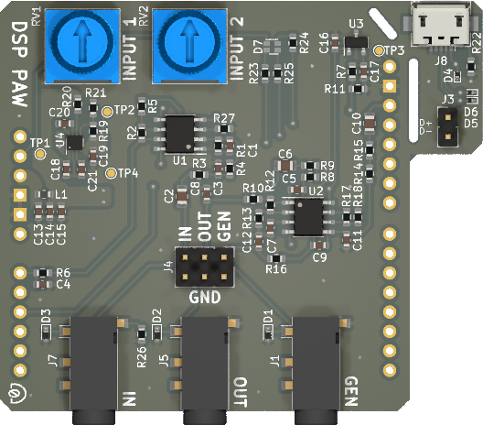  Signal input Signal output Generator output | VDDA  GND  DAC generator output  ----------------------------------------------------------------------------------------------------------------------------------------------------------------------------  USB data lines

Electrical and functional specifications

 | Min | Typical | Max | Units
Signal input | -2.0⁽¹⁾ |  | +2.0⁽¹⁾ | Volts
Signal/generator output | -2.0⁽¹⁾ |  | +2.0⁽¹⁾ | Volts
VDDA |  | 2.048 |  | Volts
USB input power | 3.6 | 5.0 | 5.5 | Volts
Sampling rate | 8 | 32⁽²⁾ | 96 | kHz
Sample buffer size | 100 | 4,096⁽²⁾ | 4,096 | count
ADC/DAC resolution |  | 12 |  | bits
Processing latency | 1⁽³⁾ | 128⁽²⁾⁽³⁾ | 512⁽³⁾ | milliseconds
Algorithm binary size |  |  | 16,384 | bytes
Algorithm stack size |  | 13,000⁽⁴⁾ | 15,360⁽⁵⁾ | bytes
⁽¹⁾ Exceeding this specification may cause damage to the microcontroller.
⁽²⁾ Default setting after power-on or reset.
⁽³⁾ Determined by sample buffer size divided by sampling rate.
⁽⁴⁾ This much stack space is guaranteed to be available for the algorithm.
⁽⁵⁾ Usable maximum is less than this due to firmware overhead. Exceeding the usable maximum
will interrupt algorithm execution.

